When GitHub will ask you to authenticate your account (by asking you to login after a push command), this is what should be done:

Note: in order to be use this entire process Gilad installed something in my computer. It can not be done from any computer.

In powershell:

gh_auth_login (enter)

enter

enter

y

enter

enter

enter

explanation: the purpose of the above process is to generate a one-time code (such as the one below, but different). You will get another number code to your phone and then you will have to insert both to specific places in the screen. You will be guided during the process.

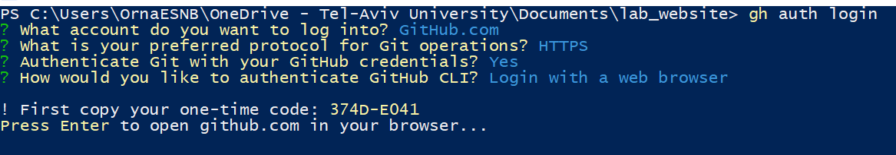

At the end you will get a screen with a big green Butten you should push (yes, I want to authenticate, bla bla!)